**See Execution Plans running with Live Query Statistics – SQL Server 2016**

In SQL Server 2016 **Live Query Statistics** is going to be the most used feature among Developers & DBAs to check the **live Execution Plan** of an active Query running in parallel.

The **Live Query/Execution Plan** will provide Real-time insights into the Query Execution process as the Control flows from one Operator to the another. It will display the overall **Query Progress** and Operator-level Run-time Execution Stats such as:

1. Number of Rows processed

2. Completion Estimate

3. Operator progress – Elapsed time & Percentage done for each Operator

4. Elapsed time & Percentage done for overall Query progress

**–>** The feature can be enable from the Toolbar, just besides the “Actual Execution Plan” icon:

[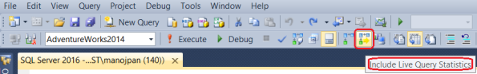](https://sqlwithmanoj.files.wordpress.com/2015/06/sql-server-2016-live-query-stats-ssms.png)

**–>** The Live Execution plan running can be seen in below animated image:

[](https://sqlwithmanoj.files.wordpress.com/2015/06/sql-server-2016-live-query-stats1.gif)

The **dotted moving** lines above shows the Operators currently in execution. As soon as the Operator finishes execution these dotted lines will change to **solid lines**.

Thus, by using this feature the user will not have to **wait** for a Query to complete its execution and then see the Execution plan stats. As soon as the user will run the Query, the Live Execution Plan will also start showing all the Operators and their progress. This will help users in checking the long running queries where actually they are taking time, and help **debugging** Query performance issues.